REQUIREMENTS:

|  |  |
| --- | --- |
| HH_1 | Calculator with basic arithmetic operations. |
| HH_2 | Scientific calculator with basic scientific fucntions |
| HH_1_LL_1 | Addition(Take 2 operands as input and perform the addition operation) |
| HH_1_LL_2 | Subtraction(Take 2 operands and subtract the 2nd operand from first)) |
| HH_1_LL_3 | Multiplication(take 2 operands as input and multiply the 1st operand with 2nd) |
| HH_1_LL_4 | Division(Take 2 operands as input from the user where 1st operator is dividend and the 2nd operator is quotient.) |
| HH_2_LL_1 | Power function(take two operators from the user and raise the 1st operand o power of 2nd operand using the pow function) |
| HH_2_LL_2 | Root function(It takes the single operand from the user as input and using sqrt function o find the squareroot of the fucntion) |
| HH_2_LL_3 | Logarithm function(take the single operand and find the lo of the opernd using the log fucntion) |
| HH_2_LL_4 | Sine function(it takes the operand from the user and return the sine of it using the math function ) |
| HH_2_LL_5 | Cos function(It takes the operand from the user and return the cosine of the operand using) |
| HH_2_LL_6 | Tan function takes the operand from the user and returns the tangent of the operand using tan operation included in math.h header file |
| HH_2_LL_7 | Cosec function takes the operand from the user and find cosecant of the operand |
| HH_2_LL_8 | Sec function takes the operand and finds the result by returning imverse of the cos function |
| HH_2_LL_9 | Cot function takes he operand and returns the inverse of the result of tangent function. |

Behavioural diagrams:

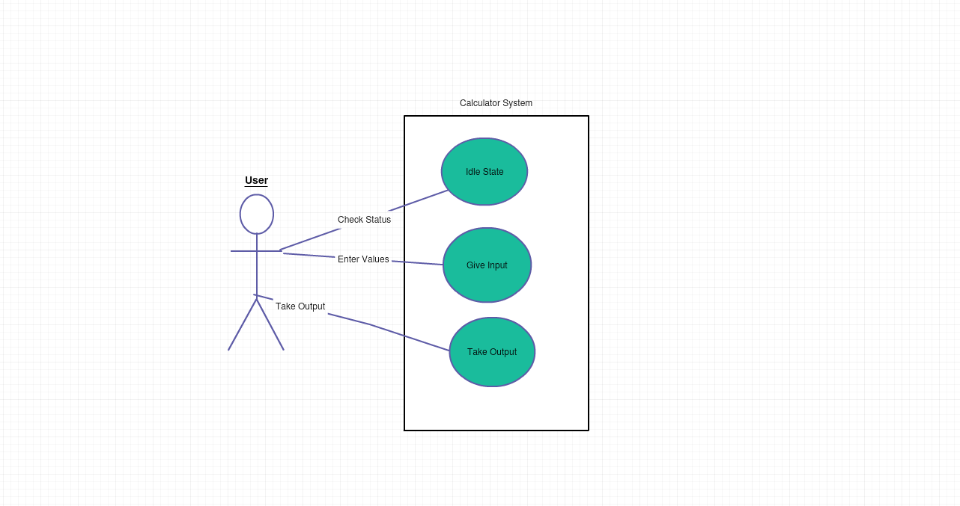

USE CASE DIAGRAM

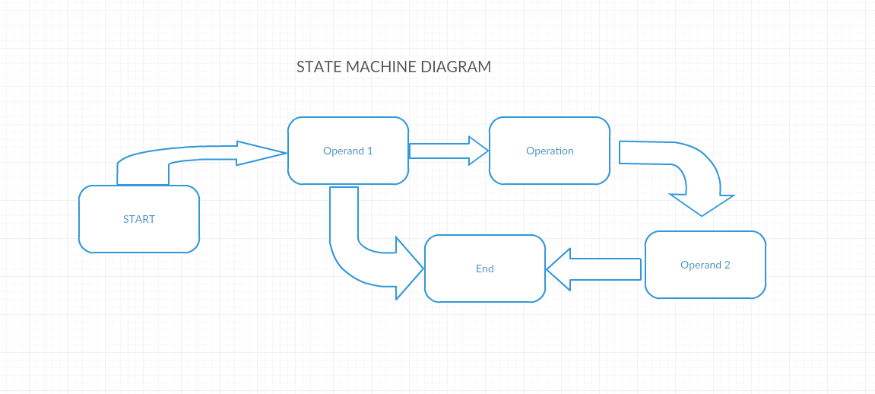

STATE MACHINE DIAGRAM 1

Structural diagrams:

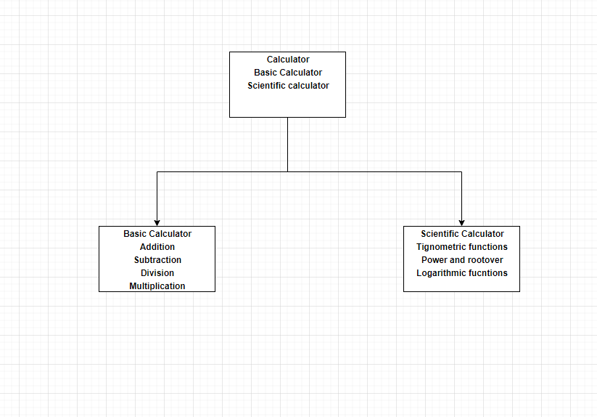

CLASS DIAGRAM 1

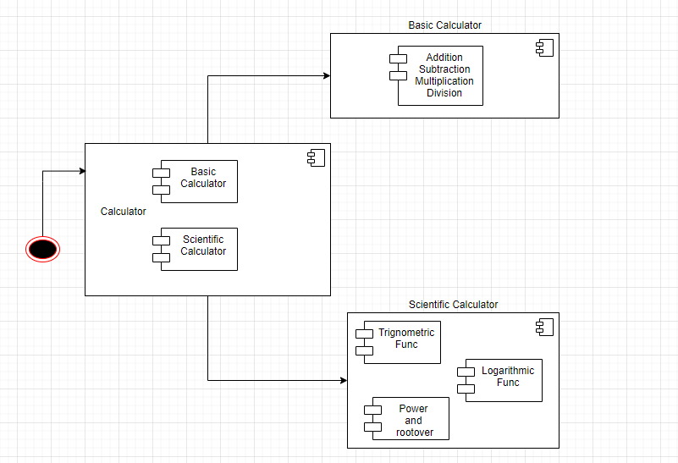

COMPOSITE STRUCTURE DIAGRAM

Test Plan:

|  |  |  |  |  |  |
| --- | --- | --- | --- | --- | --- |
| I.D. | Description | PreCondition | Expected output | Expected Input | Actual Output |
|  |  |  |  |  |  |
|  |  |  |  |  |  |
|  |  |  |  |  |  |
|  |  |  |  |  |  |

1